13th December 2016

FIA EUROPEAN TOURING CAR CUP WINNERS HONOURED

Kris Richard and Niclas Mackschin collected their FIA European Touring Car Cup trophies at a special award ceremony held in Paris recently. The Championship which has the Japanese Tyre manufacturer YOKOHAMA as exclusive tyre supplier, honoured the winners of the FIA European Touring Car Cup’s Super 2000 and Super 1600 categories at the ETCC Awards Ceremony.

Kris Richard (Switzerland) and Niklas Mackschin (Germany) collected their trophies for winning the ETCC Super 2000 Cup and ETCC Super 1600 Cup respectively as the thrilling ETCC season was celebrated in style in the French capital.

Other drivers recognised during the evening included Petr Fulín (Czech Republic) and Norbert Nagy (Hungary), who finished second and third in ETCC S2000, as well as the Germans Andreas Rinke and Kevin Hilgenhövel, who achieved second and third in ETCC S1600 class.

There was also recognition for the German motorsport federation, the DMSB, following its victory in the ETCC Nations’ Cup.

At the awards, Kris Richard (Switzerland, Honda Civic): S2000 Champion expressed his delight at the title on his first attempt and highlighted winning at the Nürburgring, the best race track on the planet, as a unique experience.

For his part Niklas Mackschin (Germany, Ford Fiesta): S1600 winner, spoke of his happiness and gratitude towards his team for the great support he received from all of them.

Meanwhile, David Oliva, responsible for Communications at YOKOHAMA Europe expressed satisfaction with the high performance of the YOKOHAMA Tyres at every race and congratulated the winners. “A big thank you to all the teams and the promoters also for their efforts throughout the season”. He added.

The 2017 FIA European Touring Car Cup season gets underway at Monza in Italy from 28th -30th April. Visits to the Hungaroring, Nürburgring Nordschleife, Vila Real, Zolder and newcomer Most follow with the Czech venue hosting the action from 6th- 8th October.

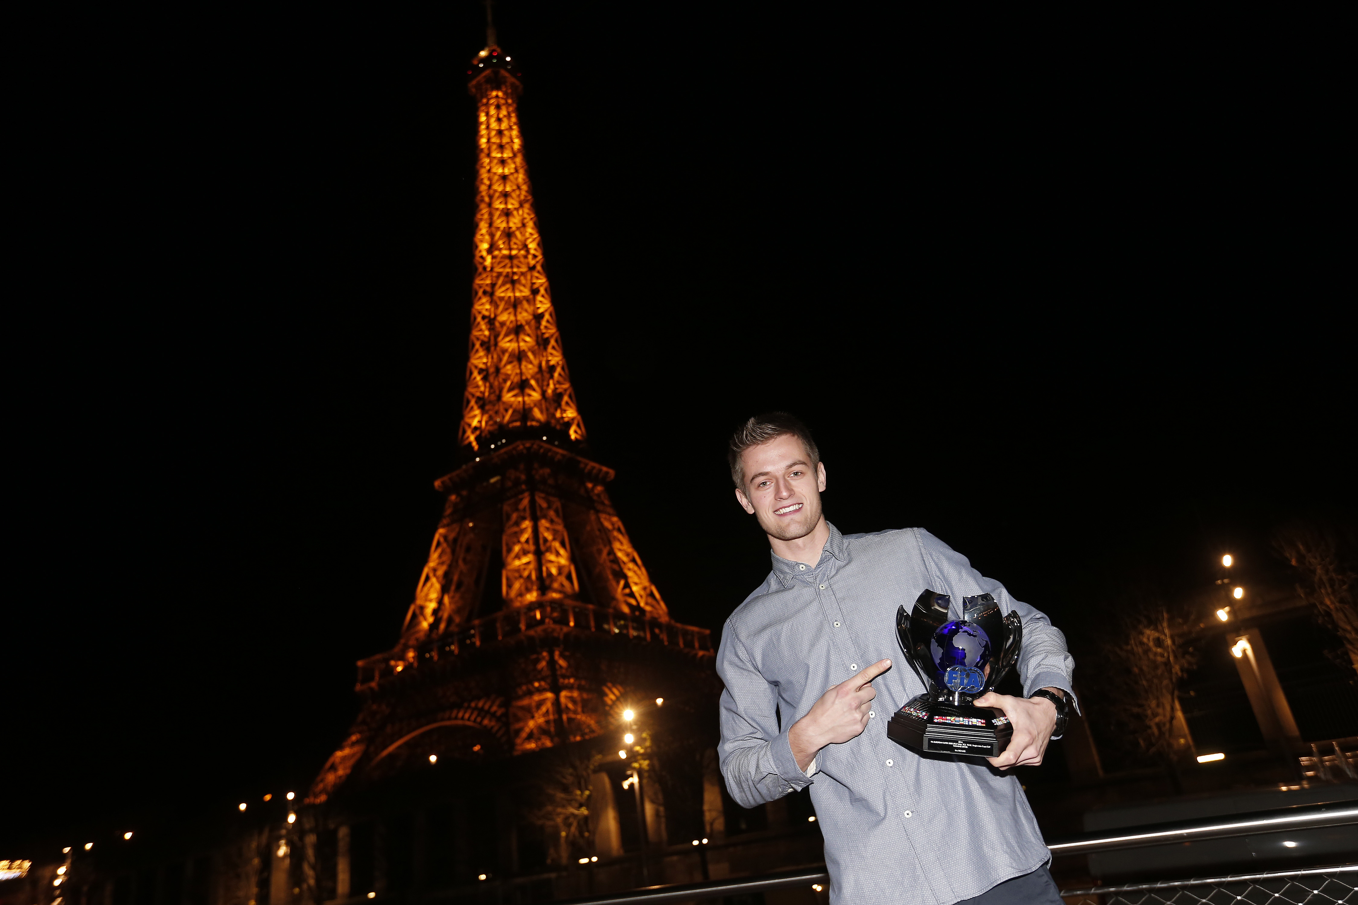
ETCC_Kris Richard

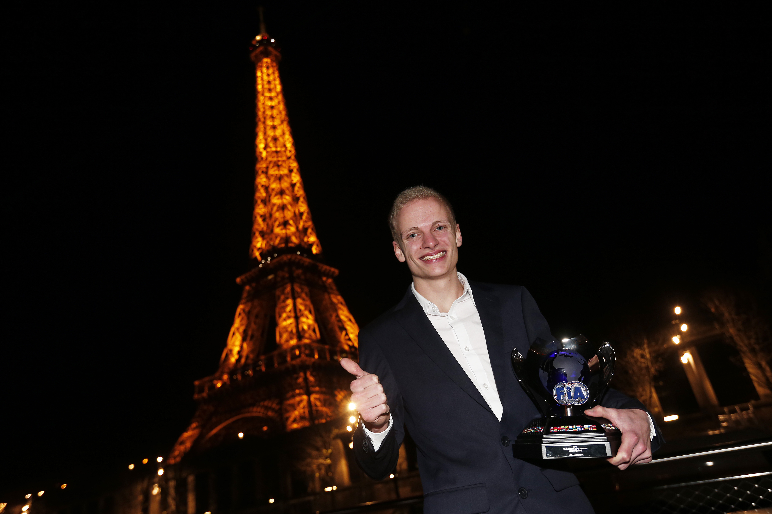
ETCC_Niklas Mackschin

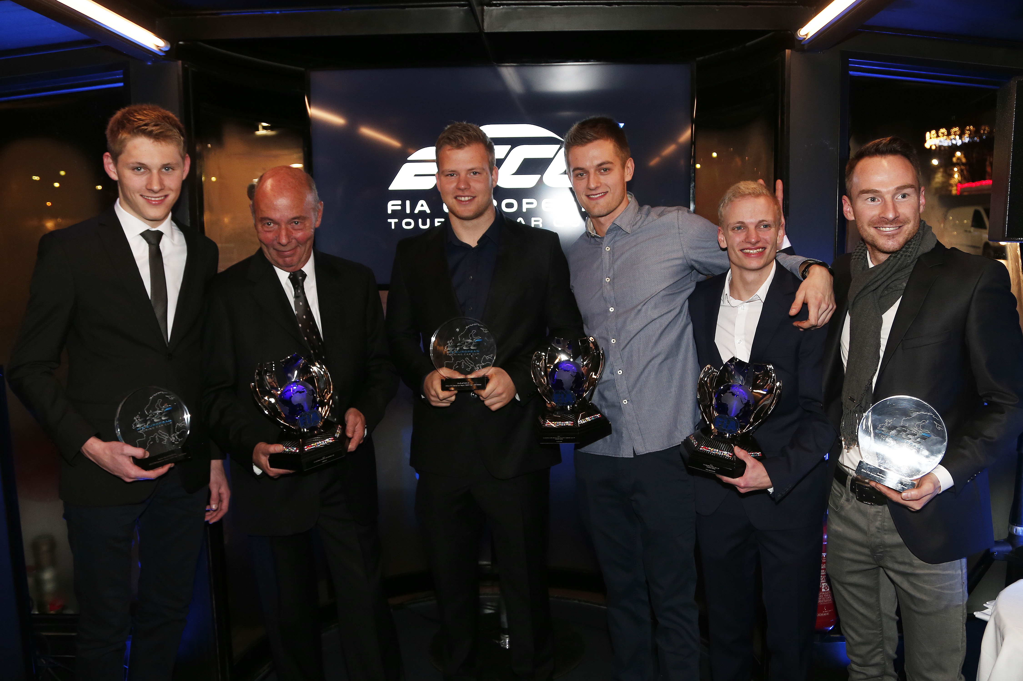
FIA_ETCC Award Winners

